Xiaopei Zhang

004309991

Session: 1A

**Apple Watch, Electric Cars and**

**The Surpassing of Humanity**

In a recent interview, Steve Wozniak, the co-founder of Apple Inc., talked about his point of view on Apple’s current latest product – Apple Watch – and his hope on Apple’s prospective manufacturing. His attitude toward Apple Watch was neutral even though some authorized assessing organizations had predicted that Apple would ship 15.4 million Apple Watch units in 2015, giving the company 54.8 percent of smartwatch market. Still, being unsure whether Apple Watches would be worth on wrist permanently, Wozniak thought they could not be the representatives of the most avant-garde achievements of Apple in technology. However, Apple should keep expanding its power into electric cars market, which had a great potential for mass sales.

Except for the watchbands and the materials, three styles of Apple Watch are the same in terms of hardware. The built-in operating system is called Watch OS whose working principles resemble those of iOS on iPhone. But unlike iPhone with a huge system of processors, chips and sensors inside, Apple Watch uses the system in package. It assembles a customized application processor, a 512MB RAM memory, 8GB storage, wireless connectivity processors and sensors as a complete computer in a single 38-inch package. Even though such a package is not able to deal with extremely tough tasks, it is sufficient for users who just run command on it and execute on the paired iPhone.

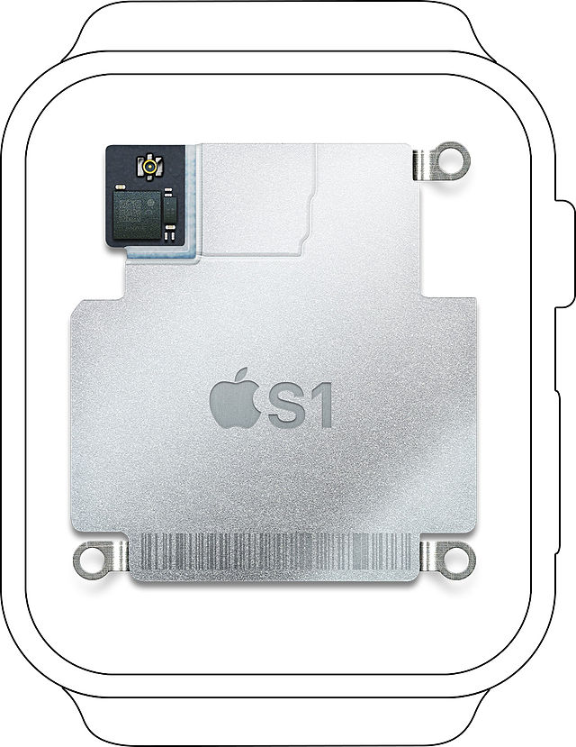

However, comparing to the similar products by Samsung and Microsoft, Apple Watch does not win the battle on the setup and the design (especially the power source, which dies in less than 18 hours). As Wozniak indicated in the interview, a crucial factor that might eventually help Apple win would be the emergence of one or several apps that made it hugely advantageous to wear the watch all the time. And apparently, Apple is catalyzing this by offering a platform on Xcode, named WatchKit, for great software engineers around the world. Succinctly speaking, WatchKit just builds the bridge between Apple Watch and its connected terminal. When the app is launched on Apple Watch, the WatchKit extension on iPhone runs in the background to update the user interface and respond to user interactions. Nowadays, there aren’t many applications running independently on Apple Watch. It must be an extraordinary progress if an application that keeps users focusing and clicking on the watch appears one day.

At the same time, Wozniak reminded Apple that building electric vehicles should be put into Apple’s blueprint as soon as possible since electric vehicles are guaranteed to replace those burning fossil fuels in decades. Definitely, driving electric cars reduces gas emission and air pollution and besides that, the on-board efficiency of electric cars is astonishing – around 80 percent, which means triple efficiency of current automobiles. Battery is the core of electric vehicles. It not only supplies torque to electric motor, but also keeps the motor rotating smoothly and steadily with the help of the controller. That’s why some reports suggested that Apple had been aggressively seeking to hire experts in battery making, and even willing to offer $US250, 000 to employees of Tesla Motor. Another key component is the motor’s controller mentioned above, which serves as a signal processor and regulator to generate sine-shaped electromagnetic pulses to the motor. It works by reading the setting of the accelerate pedal. If the driver push the accelerate pedal halfway down, the controller reads that setting and swiftly switches the power to the motor on and off so that it is on half the time and off half the time. A better controller will make the processed power signal more continuous and smooth.

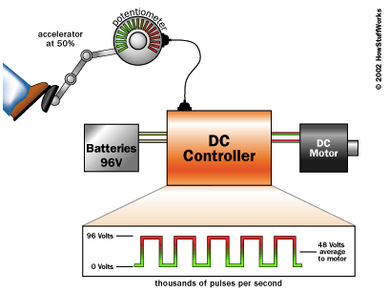

As Wozniak said, electric vehicles, which merely comprised 1% of all automobiles sold in the United States, would be extraordinarily profitable as long as more and more people were aware of how efficient and convenient they could be. Fortunately, the threshold to enter this market became relatively low as huge enterprises like Tesla made its patent open source freely available. After all, the more we spur competition, the faster electric cars industry develops.

However, such rapid developments of electrical industries and computers these years did not delight Wozniak at all. He tentatively gave a negative answer to the question that should we let computers grow as much as possible. Numerous pessimistic predictions imply that if we construct devices that are able to perfectly simulate or attain human consciousness, finally they will think and execute faster than us and get rid of slow humans to efficiently run companies. The worst outcome may be that computers take over humans thoroughly. One possible approach to increase our control over computers is to develop quantum computers, which handle and analyze the data in sub-atomic level. Theoretically, quantum computers run on qubits, which can be zero or one at the same time, rather than bits (can be either zero or one at a time). According to Moore’s Law, the number of transistors on a microprocessor will double every 18 months, so by 2020 or 2030, the transistors will be measured in atomic scale. At that time, atoms and molecules, instead of silicon chips and semiconductors, will perform complex calculations a lot more rapidly than modern computers. Although the quantum computer is still at its infancy, I anticipate a great leap in a few decades.

To some degree, scientific predictors are always superstitious, improvident and unknown about the future. For example, in London, Dr. Lardner (1793-1859) thought that high-speed railway transportations were ridiculous since passengers would be hard to breathe and choke to death. But China had already got 98,000km of conventional railways and 9356km of high-speed lines in operation by the end of 2012. Another example is about Albert Einstein who predicted that nuclear energy could never be used properly since humans could not tear atoms into parts. But in fact, almost 20 percent of all energy used in the United States every year is from nuclear energy. In my opinion, scientific predictions should be treated more like warnings rather than burdens. As long as we remember to prepare some feasible measurements to protect humanity, our life will be better and brighter.

**Work Cited:**

1. “Apple co-founder Steve Wozniak on the Apple Watch, electric cars and the surpassing of humanity” (2015-03-23):

<http://www.afr.com/technology/apple-cofounder-steve-wozniak-on-the-apple-watch-electric-cars-and-the-surpassing-of-humanity-20150323-1m3xxk>

1. Apple S1: <https://en.wikipedia.org/wiki/Apple_S1>
2. WatchKit: <https://developer.apple.com/watchkit/>
3. Apple Watch Sale Situation:

<https://www.cnet.com/news/how-well-did-the-apple-watch-sell-tim-cook-remains-mum/>

1. “How Electric Cars Work”: <http://auto.howstuffworks.com/electric-car.htm>
2. “Quantum Computing”: <http://en.wikipedia.org/wiki/Quantum_computing>
3. “How Quantum Computers Work”:

<http://computer.howstuffworks.com/quantum-computer.htm>

1. ["China implements radical railway reform"](http://www.railjournal.com/index.php/policy/china-implements-radical-railway-reform.html). *International Railway Journal*, 2013-08-02
2. Nuclear Energy Institute Website, 2009-02-23